**DAILY ONLINE ACTIVITIES SUMMARY**

|  |  |  |  |  |  |  |  |
| --- | --- | --- | --- | --- | --- | --- | --- |
| **Date:** | **20 MAY 2020** | | | | **Name:** | **KHATHEEJA SAFREENA** | |
| **Sem & Sec** | **4th sem 'A'** | | | | **USN:** | **4AL18CS037** | |
| **Online Test Summary** | | | | | | | |
| **Subject** | | **OOC** | | | | | |
| **Max. Marks** | | **30** | | **Score** | | **14** | |
| **Certification Course Summary** | | | | | | | |
| **Course** | **1.JAVA PROGRAMMING.** | | | | | | |
| **Certificate Provider** | | | **Great learning** | **Duration** | | | **3.5 hr** |
| **Coding Challenges** | | | | | | | |
| **Problem Statement: I have mentioned the 4 problem statements below.** | | | | | | | |
| **Status: completed** | | | | | | | |
| **Uploaded the report in Github** | | | | **Yes** | | | |
| **If yes Repository name** | | | | **[http://shafreenasharief / lockdown-coding](http://shafreenasharief / lockdown-coding" \o "http://shafreenasharief / lockdown-coding)** | | | |
| **Uploaded the report in slack** | | | | **Yes** | | | |

Online Test Details: (Attach the snapshot and briefly write the report for the same)

Certification Course Details: (Attach the snapshot and briefly write the report for the same)

Coding Challenges Details: (Attach the snapshot and briefly write the report for the same)

ONLINE TEST DETAILS:

Today OBJECT ORIENTED CONCEPTS was conducted of first module. Total marks for the test was 30.The online test conducted includes MCQ kind questions and also output prediction.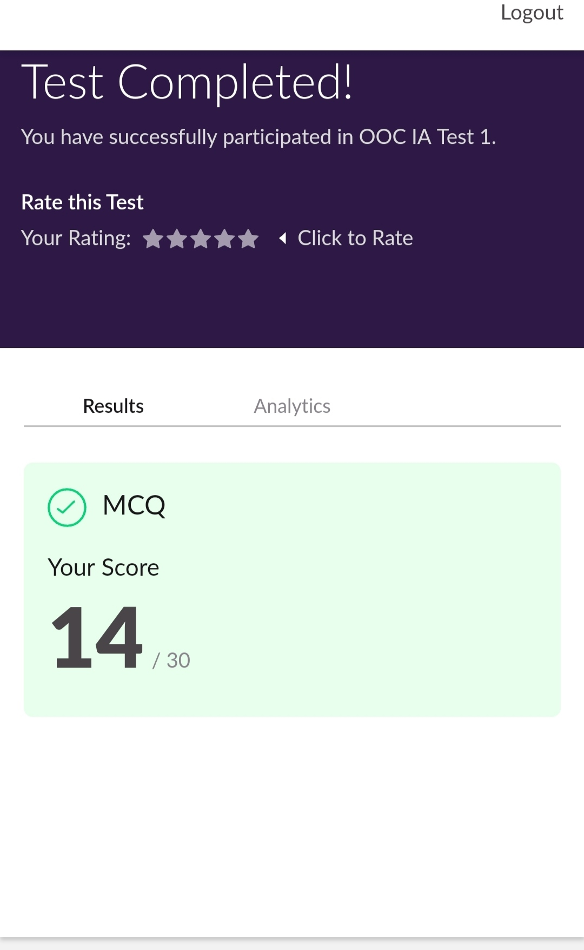

CERTIFICATION COURSE DETAILS:

* Today I started new certificate course through Great learning. I choose the concept of Java programming. I learnt about Agenda, what is java, Installing of java and java IDK, First java program, Variables and Data types, Operators in java, Flow Control Statements in java.I attempted quiz ,which gave me a clear veiw about the topics that were thought and discussed
* It consists of 11 modules including assessments.

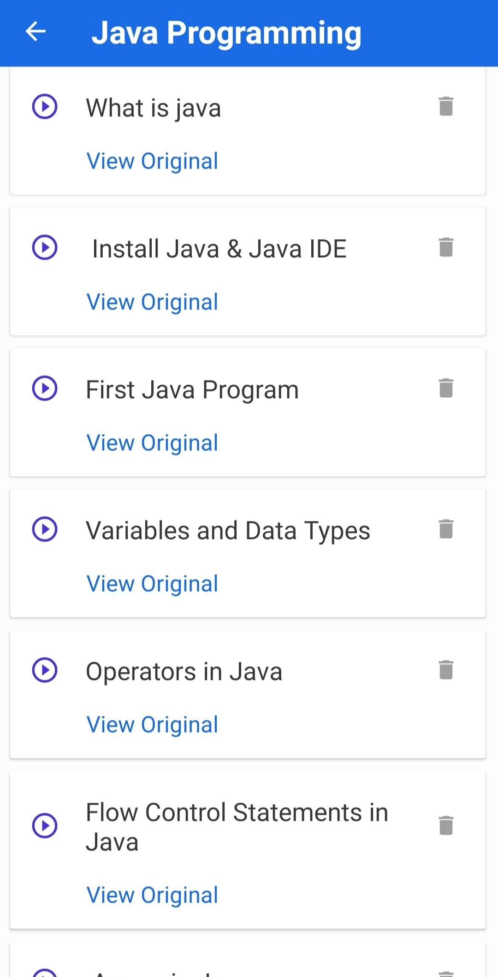

* Im completing modules on this course.

**Coding Challenges:**

Today I solved 4 coding challenge,

1. Related to linked list:

Test Case 1:

If a linked list is: 1 → 2 → 3 → 4 → 5 → 6 → 7 → 8

The value of size k is 2

Then the linked list looks like: 2 → 1 → 4 → 3 → 6 → 5 → 8 → 7

Test Case 2:

If a linked list is: 1 → 2 → 3 → 4 → 5 → 6 → 7 → 8

The value of size k is 3

Then the linked list looks like: 3 → 2 → 1 → 6 → 5 → 4 → 8 → 7

2. program print Duplicates which prints the duplicate elements of the given array:

Given an array a[] of size n which contains elements from 0 to n-1, write a program to print Duplicates which prints the duplicate elements of the given array. If no duplicate element is found print -1.

Input:

The first line of input must contain an integer n which denotes number of elements of Array. Second line contains n space separated integers denoting elements of array a[].

*Output:*

*Print the duplicate elements from the given array.*

3. **First come First Served related and Shortest Job First related:**

**Write a C or Java program to implement FCFS and SJF process scheduling.  
 Input: Processes with burst time  
 Output: Process being scheduled**

SOLUTION : I have uploaded the solution of the above 4 coding problems in my GitHub repository.

[http://shafreenasharief / lockdown-coding](http://shafreenasharief / lockdown-coding" \o "http://shafreenasharief / lockdown-coding)

